Harvester Christian Church
Life Groups | PERSONAL BIBLE STUDY | Matt Salin
ENTRUSTED | RELENTLESSLY INTENTIONAL WITH LIFE’S TIME

WEEK 0

SO...WHAT'S THE POINT OF LIFE?
How would you respond if someone were to ask you, "What is the point of life?" Thankfully, God's Word has much to say about this exact topic. Read and briefly summarize the below passages:
• Matthew 6:33

• Ecclesiastes 12:13-14

• Micah 6:8

• Colossians 3:23-24

• Colossians 4:5

• Mark 12:30-31

• Philippians 4:6

• 1 Corinthians 10:31

NUMBERED DAYS // YOUR LIFE'S TIME IN HIS STORY
Read Psalm 90:1-6 --> God has an eternal perspective and wider context on our lives than we do; what words would you use to describe life after reading this?

Read Psalm 90:12 --> What does it mean to number our days?

How do you live as though your days are numbered?

What changes would you like to make?

What are you willing to do?

TIME IS TICKIN' AWAY // MAKING YOUR PRIORITIES A PRIORITY
Read Matthew 6:25-34 --> How do those around you know that you seek God first?

Who are some examples in your life that seek God first in all things? Consider connecting with them this week to share this and encourage them.

Worrying is a waste of time. What are you wasting time worrying about this week? Read 1 Peter 5:7 and pray that God reveal something specific where you need to "cast your anxiety" to Him.

Read Colossians 4:5 --> Where are you missing opportunities to share Christ? What are you willing to do about it?

WEEKLY CHALLENGE - MEASURE/RE-PRIORITIZE/COMMIT
Measure
We each have the same 24 hours to make wise decisions with each day. This week, make an effort to measure how you currently choose to spend your 24 hours per day. There are some helpful tools that can make this as "easy and high-level" or "challenging and detailed" as you'd like:

• SMARTPHONE APPS - ATracker (iOS), Eternity (iOS), Jiffy (Android): Use the same categories as below
• PENCIL & PAPER - ESTIMATE how much time you spend on each of these common activities on an average day:

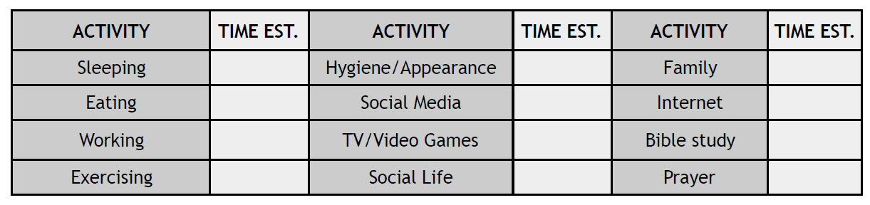

Re-Prioritize
- What did this activity reveal to you about WHAT and WHO you are prioritizing with your time?

- If you were to create a monthly "time budget" that reflected how you WANT TO spend your time, what/who would be your biggest 4-5 priorities?

- What is your biggest obstacle in the way of your prioritizing your time differently?

Commit
- What are you willing to do about it?

- PRAY ABOUT THIS and be prepared to share with your Life Group and, if appropriate, seek accountability.

GROUP DISCUSSION QUESTIONS
1. Is there anything else you wanted to talk about from the lesson or homework?
2. Are you taking your life's time seriously enough? What would your life look like if you spent your time in a "relentlessly intentionally" manner? How might you be a more effective disciple for Christ?
3. As you consider how you currently choose to "budget" your time, how would you like to "spend" your life's time differently?
4. Is the will of God your conscious top priority?
5. Are you asking God, "What do you want to do with me?" If so, what is He saying?
6. Do the people that matter the most to you know that God's will is a primary passion for you?
• If not, what's hindering this?
• What are you willing to do?

